Deerwalk Institute Of Technology
Internet Technology

Submitted By: Submitted To:
Name: Sagar Giri Sudhir Maharjan
Roll No. 205

Date: July 15th 2016
Introduction
Joomla is an open source Content Management System (CMS), which is used to build
websites and online applications. It is free and extendable which is separated into front-
end templates and back-end templates (administrator). Joomla is developed using PHP,
Object Oriented Programming, software design patterns and MySQL (used for storing the
data).

Installation:
1. First download Joomla from http://www.joomla.org/download.html
2. Extract into a folder (say: joomlasite)
3. Copy the extracted folder to /var/www/html/
3. Go to browser and type (http://localhost/joomlasite/). It will take us to the installation wizard.
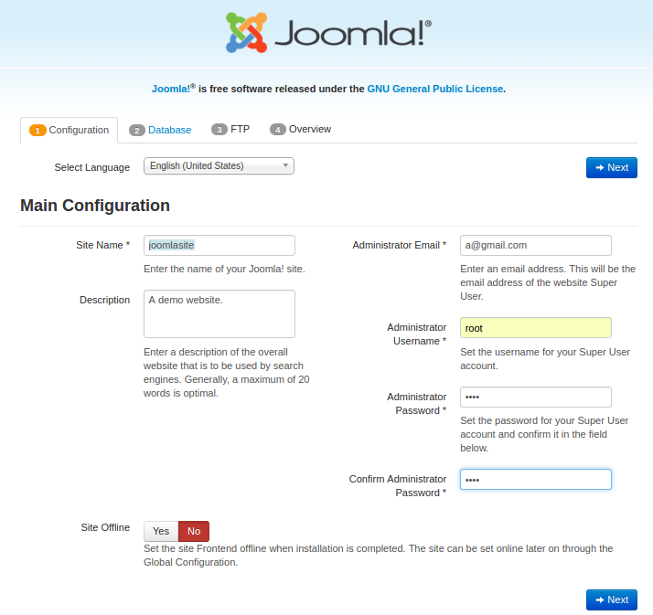
Fill the Configuration form and proceed to Database configuration.

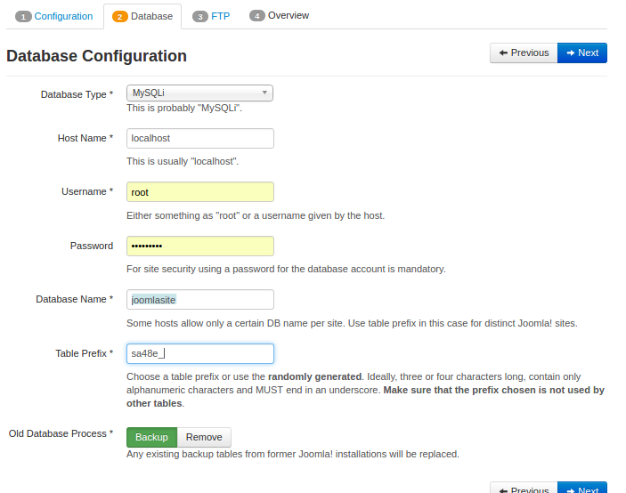
To configure the database, first we should create database in MySQL database. In the database configuration, fill up the database username and password, database name and table prefix. Table prefix is must since, it is random, prevents from unauthorized access of our website database.
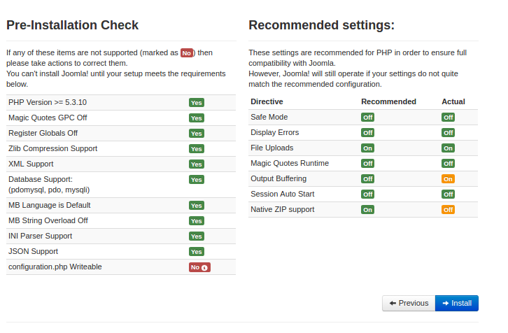
Lastly, joomla installation wizard will check all the configuration. Now, pressing Install button proceeds us to the installation phase.
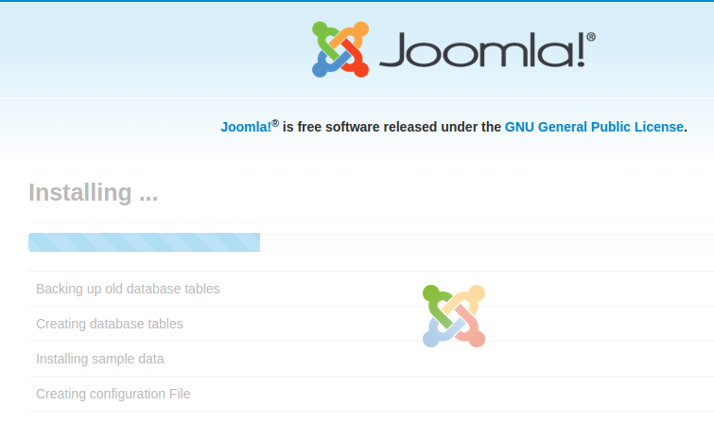
We can login to admin panel, from the URL: localhost/joomla/administrator

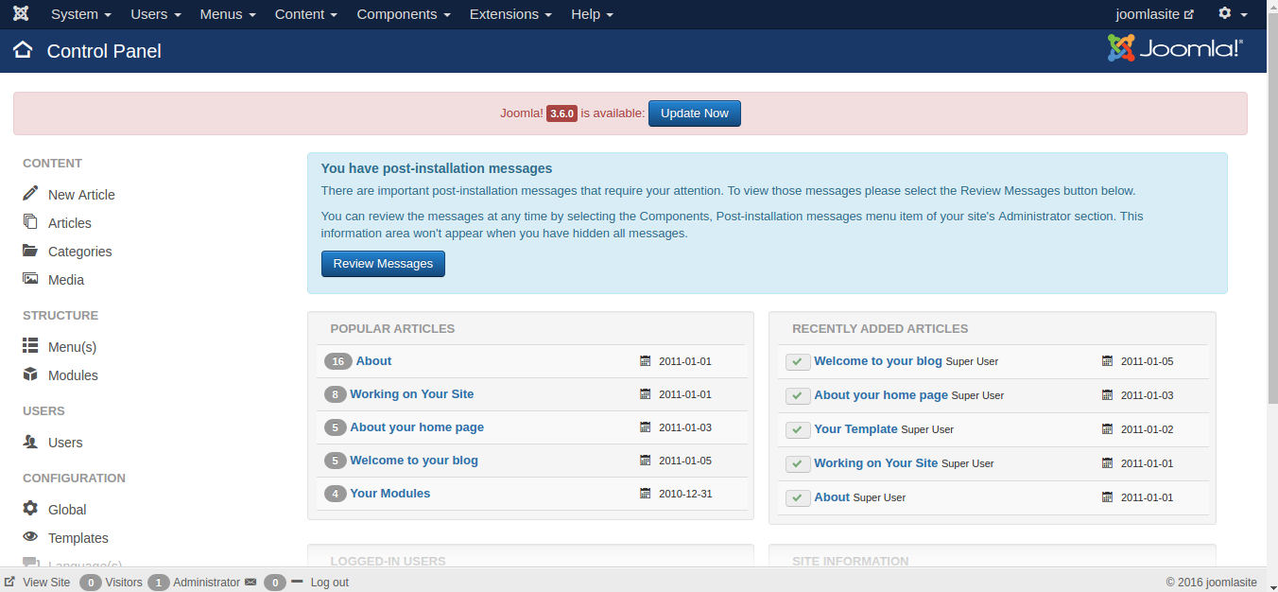
Admin panel
From the admin panel, we can control all our configuration for our website/ blog.

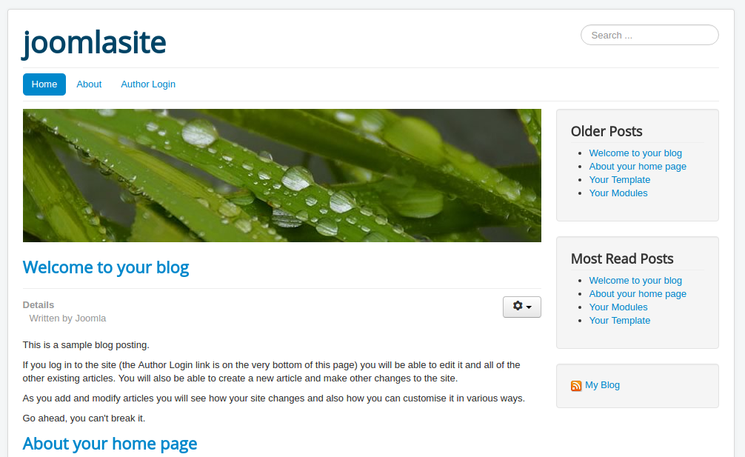
Website preview

URL: localhost/joomasite is the URL for our homepage.
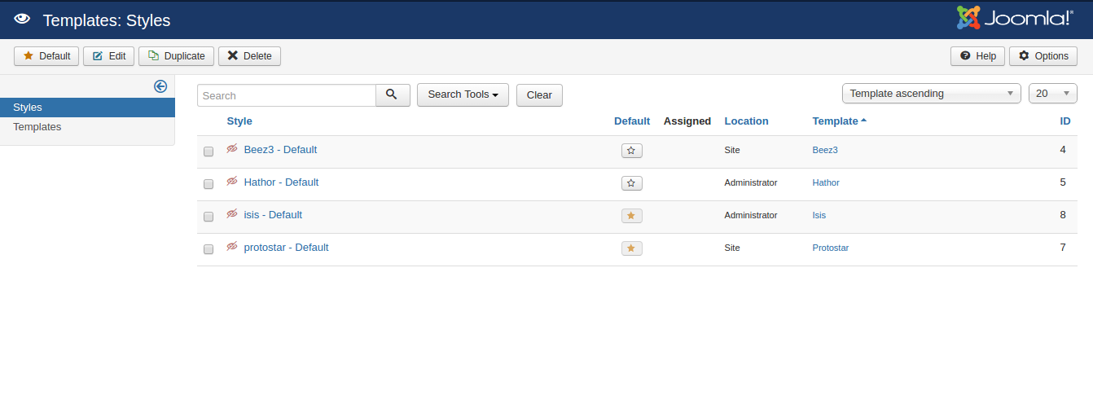
Form templates > Styles we can control the view of our website as well as the admin panel.

From menu section, we can change the menu of our website. Saving the configuration is reflected to our website.

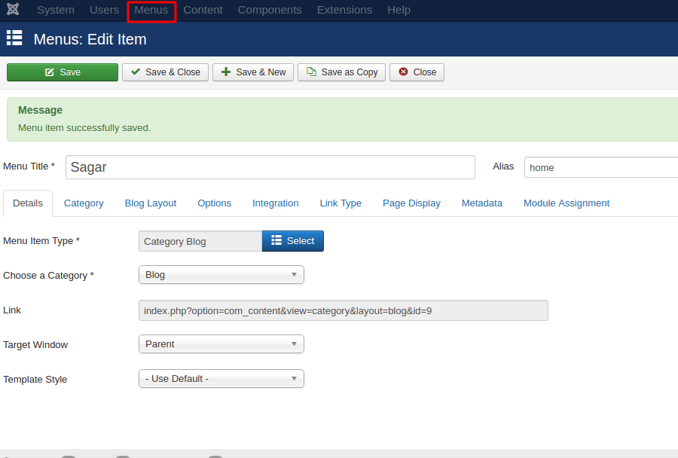

From Articles section, we can change/ add new blog posts.

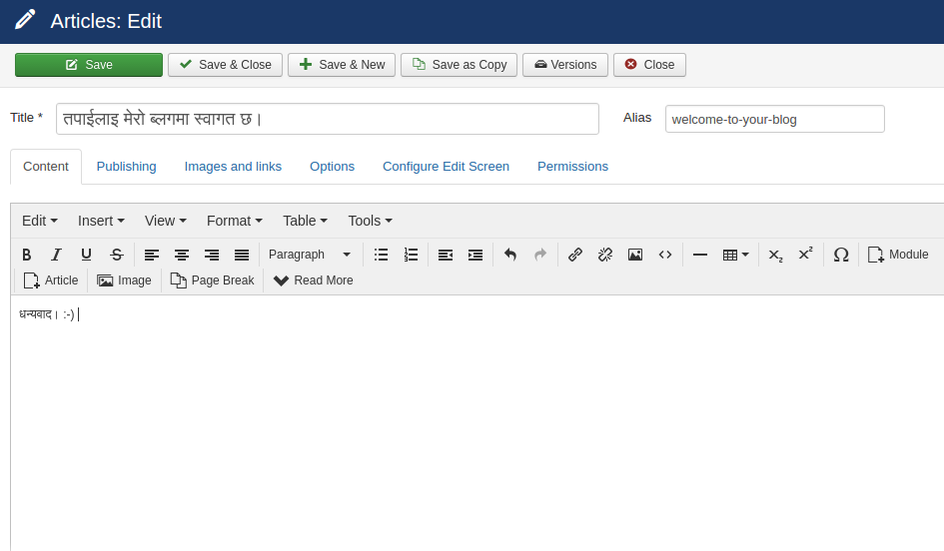

After all configuration and changes, we can view our new website.
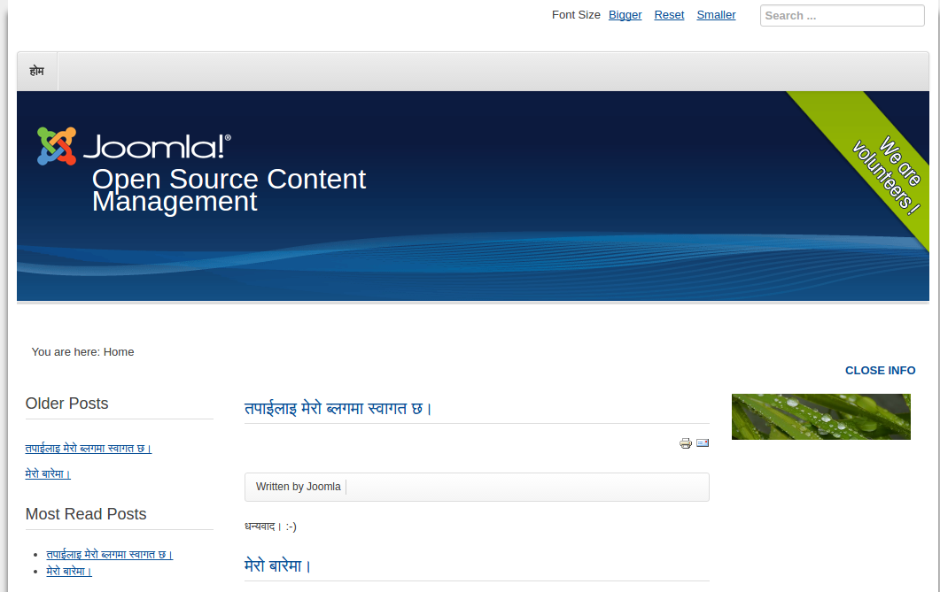
Final Preview

